# **AUTOMOTIVE INSURANCE SYSTEM**

**A Project Report**

***Submitted by***

## **HARSH AGARWAL**

**AMIT BIRAJDAR**

**MANAN BOLIA**

**VEDANG GUPTE**

***Under the Guidance of***

## **PROF. ANSHUL VYAS**

***in partial fulfillment for the award of the degree of***

## **BACHELOR OF TECHNOLOGY**

**IN COMPUTER ENGINEERING**

## **At**



**MUKESH PATEL SCHOOL OF TECHNOLOGY MANAGEMENT AND ENGINEERING**

**OCTOBER, 2019**

**CERTIFICATE**

This is to certify that the project entitled “**Automotive Insurance System**” is the bonafide work carried out by **Harsh Agarwal, Amit Birajdar, Manan Bolia and Vedang Gupte** of B.Tech (Computer Engineering), MPSTME (NMIMS), Mumbai, during the VIII semester of the academic year 2019-20, in partial fulfillment of the requirements for the award of the Degree of Bachelors of Engineering as per the norms prescribed by NMIMS. The project work has been assessed and found to be satisfactory.

_________________

**Prof Anshul Vyas Internal Mentor**

**______________ ______________**

**Examiner 1 Examiner 2**

**_______________**

**Dean**

**Dr. N.T.Rao**

## **DECLARATION**

I, Harsh Agarwal, B004, Amit Birajdar, B014, Manan Bolia, B015 and Vedang Gupte B019, B.Tech (Computer Engineering), VIII semester understand that plagiarism is defined as anyone or combination of the following:

1. Un-credited verbatim copying of individual sentences, paragraphs or illustration (such as graphs, diagrams, etc.) from any source, published or unpublished, including the internet.

2. Un-credited improper paraphrasing of pages paragraphs (changing a few words phrases, or rearranging the original sentence order)

3. Credited verbatim copying of a major portion of a paper (or thesis chapter) without clear delineation of who wrote what. ( Source:IEEE, The institute, Dec. 2004)

4. I have made sure that all the ideas, expressions, graphs, diagrams, etc.that are not a result of my work, are properly credited. Long phrases or sentences that had to be used verbatim from published literature have been clearly identified using quotation marks.

5. I affirm that no portion of my work can be considered as plagiarism and I take full responsibility if such a complaint occurs. I understand fully well that the guide of the seminar/ project report may not be in a position to check for the possibility of such incidents of plagiarism in this body of work.

Signature of the Student:

Name: Harsh Agarwal, Amit Birajdar, Manan Bolia, Vedang Gupte

Roll No. B004, B014, B015, B019

Place: NMIMS’ MPSTME, Mumbai

Date: 12th October, 2019

**ACKNOWLEDGEMENT**

This project would not have been possible without the kind support and help of many individuals and organizations. We would like to extend our sincere thanks to all of them. We are highly indebted to Prof. Anshul Vyas for his guidance and constant supervision as well as for providing necessary information regarding the project and also for his support at every stage of this project. We would also like to thank our peers for providing helpful insights at every stage of the project.

Harsh Agarwal (B004)

Amit Birajdar (B014)

Manan Bolia (B015)

Vedang Gupte (B019)

**ORGANISATION OF REPORT**

This report is divided into 6 chapters. Chapter 1 introduces the basic concept and motivation for the project.Chapter 2 contains the literature survey which consists of a summary of all the research papers and websites used to gain an idea on how to implement the project.Chapter 3 contains analysis and design.Chapter 4 describes the methods and technologies used to implement the functionalities.Chapter 5 states the observations and results of the implementation. Chapter 6 consists of the conclusion and the future scope of the project.This is followed by a list of references. An appendix is given at the end of the report.

**Table of Contents**

|  |  |  |
| --- | --- | --- |
| **CHAPTER NO.** | **TITLE** | **PAGE NO.** |
|  | List Of Figures | 6 |
|  | List Of Tables | 7 |
|  | Abbreviations | 8 |
|  | Abstract | 9 |
| 1 | INTRODUCTION | 10 |
|  | 1.1 Project Overview | 10 |
|  | 1.2 Motivation and Scope | 10 |
|  | 1.3 Salient Features | 11 |
| 2 | REVIEW OF LITERATURE | 12 |
|  | 2.1 Efforts by insurers | 12 |
|  | 2.2 Existing dent detection technologies | 13 |
|  | 2.3 Neural networks | 16 |
|  | 2.4 Web Scraping | 18 |
| 3 | ANALYSIS & DESIGN | 19 |
| 4 | METHODS IMPLEMENTED | 21 |
| 5 | RESULTS & DISCUSSION | 26 |
| 6 | CONCLUSION & FUTURE SCOPE | 30 |
|  | REFERENCES | 32 |
|  | APPENDIX | 34 |

**List of Figures**

|  |  |  |
| --- | --- | --- |
| **CHAPTER NO.** | **TITLE** | **PAGE NO** |
| 3 | ANALYSIS & DESIGN | 19 |
|  | Fig 3.1 : Use Case Diagram showing the overview of the proposed system | 19 |
|  | Fig 3.2 : Sequence Diagram representing steps for raising new claim / estimate request | 20 |
| 4 | METHODS & IMPLEMENTATION | 21 |
|  | Fig 4.1 : The original input image | 21 |
|  | Fig 4.2 : The output image received using first method. | 22 |
|  | Fig 4.3 : The output image received using second method. | 22 |
|  | Fig 4.4 : Homepage of website | 23 |
|  | Fig 4.5 : Information page about  Ibot | 24 |
|  | Fig 4.6 : Gallery of processed images | 24 |
|  | Fig 4.7 : Query form | 25 |
|  | Fig 4.8 : Login page | 25 |
| 5 | RESULTS & DISCUSSION | 26 |
|  | Fig 5.1 : Dent demarcated properly | 26 |
|  | Fig 5.2 : Dent demarcated properly | 26 |
|  | Fig 5.3 : Dent demarcated | 27 |
|  | Fig 5.4 : Multiple damages are demarcated | 27 |
|  | Fig 5.5 : Multiple damages are demarcated | 28 |
|  | Fig 5.6: Multiple damages but not all marked | 28 |

**List of Tables**

|  |  |  |
| --- | --- | --- |
| **CHAPTER NO** | **TITLE** | **PAGE NO** |
| 2 | REVIEW OF LITERATURE | 12 |
|  | Table 2.1: Insurance Claim Technologies | 12 |
|  | Table 2.2: Dent Detection Technologies | 13 |
|  | Table 2.3: Neural Network Algorithms | 16 |
|  | Table 2.4: Web Scraping Methods | 18 |

**Abbreviations**

|  |  |
| --- | --- |
| **Abbreviations** | **Description** |
| CNN | Convolution Neural Network |
| RCNN | Regional - Convolution Neural Network |
| YOLO | You Only Look Once |
| PHP | Hypertext Preprocessor |
| SQL | Structured Query Language database |
| AJAX | Asynchronous JavaScript and XML |

**ABSTRACT**

This project aims to build an intelligent system for the users to help them with their car insurance. They can get an estimate of the insurance amount which may be provided to them from their respective insurance companies as the “Insurance Claim Amount” to cover the damages for their vehicle. This is very subjective as different users will have different insurance companies/agents for their insurance and within that, a company/agent might also have different policies for different users. The platform provided to the users is a website where they can register and avail its services. The user is prompted to enter basic information like car make, model, insurance company and type of insurance policy user has, along with images of the damaged parts of the vehicle on the website. Also, the user has to answer a questionnaire developed by us based on the learnings of the past accidents which helps the software to know the degree or the extent of the actual internal damages suffered by the car because of the accident. This mostly tells the software about the non-cosmetic(engine and transmission) category of damage suffered by the car. The images are sent to the server where a software uses Mask RCNN algorithm to analyze and detect the dents. The estimate is calculated using previous data from the database and other problems are diagnosed based on the information given by the user through the questionnaire. This estimate is sent to the user as a guesstimate for the claimed amount. This project provides a quick and on-spot approximation of the insurance amount, and thus drastically reduces the time taken to provide an initial estimate compared to conventional approaches where the insurance company agent would come and analyze the damage and then send a claim amount in 2-3 business days to user. Thus, it also strives to make the process more convenient by eliminating the need of middlemen for initial assessment. Now, finally the user can decide whether he wants to go for the insurance claim or just get his car repaired for a mechanic in the neighbourhood.

**1. INTRODUCTION**

**1.1. Project Overview:**

* The objective of the project is to build a system where users can get an estimate of the insurance amount that can be claimed for damages to their vehicle, in a small amount of time.
* The aim of this project is to reduce the redundant aspect i.e. human involvement required and deliver desired results in a very short period of time.
* Users can access the service through a website
* Image submitted by the user through the website will be analysed by the system and an estimate will be provided to him consequently.
* System can detect internal damages through a set of questions answered by the user while the results for the damage are being calculated.
* As a result, the system will provide the complete cost to the user.

**1.2 Motivation and scope:**

The number of cars in metropolitan cities is at an all time high, and rural penetration is increasing every day.With such increase in the number of vehicles on the road, there is also an increase in the number of accidents. Most of the damages are covered through an insurance policy, but there is no clarity as to the amount that can be claimed in case of any damages. The process for claiming insurance is long and arduous. The insurance company may take weeks to give an estimate of the claimable amount before any repairs commence. The owner of the vehicle may thus wish to instantly get an initial estimate. This project aims to provide an approximate estimate by detecting the damage and using a database to derive information about the amount that can be claimed based on the policy, make of the car, and damages. Moreover any internal damage is also assessed based on a questionnaire provided to the user. This makes it easy and convenient for a user to get an idea about what amount can be claimed.

Due to database and system constraints, the scope will be limited to passenger vehicles manufactured by Hyundai Motor Company.

**1.3 Salient Features:**

* User can input images of damaged area.
* A questionnaire is provided for assessing internal damage.
* A possible list of problems will be emailed to the user.
* An estimate of the claimable amount is also emailed to the user.

**2. REVIEW OF LITERATURE**

**2.1 Efforts By Insurers**

The following papers were read to get a clear idea of the ground reality in how insurance claims are processed and the existing efforts by insurers to digitize the process of insurance surveyance and whether any implementation similar to the proposed idea has been carried out.

Table 2.1: Insurance claim technologies

|  |  |  |  |
| --- | --- | --- | --- |
| Author(s) | Title | Aim | Findings |
| Ravi Malhotra,Swati Sharma,  Accenture | Machine Learning in Insurance | Summarize the different ways in which machine learning is used by insurers | Machine learning can be used for claims processing. But due to associated investments and risks it has not been heavily adopted by insurers |
| ICICI Lombard | Intraspect:Instant claim approval | Develop an automated claim processing software to eliminate physical inspection | This approach uses a video recording to analyze the damage to the car. It is not possible to send a picture of only affected areas. |
| Madan Mohan Dutta, Gautam Mitra | Factors Affecting Auto Insurance In India | Summarize the factors that affect insurance premiums and claims | Learnt about different types of insurance policies for automobiles |

**2.2 Existing Dent Detection Technologies**

We decided to learn about existing technologies that are used by manufacturers to detect flaws in the panels of their cars.This helped us get an idea of the industry standards and assess whether these could be used in the project for dent detection.

Table 2.2: Dent Detection Technologies

|  |  |  |  |
| --- | --- | --- | --- |
| Author(s) | Title | Aim | Findings |
| Laura Arnal, J.Ernesto Solanes, Jaime Molina, Josep Tornero | Detecting dings and dents on specular car body surfaces based on optical flow | Dent detection Using well-known optical flow algorithms and the deflectometry principle | Fast enough to meet assembly line industry standards.Resource intensive and also requires specialised equipment.Cannot detect scratches |
| T. Lilienblum, P. Albrecht, R. Calow,B. Michaelis | Dent detection in car bodies | Automatic dent detection for unpainted panels | Fast and accurate but requires prior knowledge of exact dimensions of parts.Fails if paint is damaged,and cannot detect scratches |
| Qinbang Zhou, Renwen Chen, Bin Huang, Chuan Liu, Jie Yu, Xiaoqing Yu | An Automatic Surface Defect Inspection System for Automobiles Using Machine Vision Methods | Classification of dents and scratches by feature extraction and a support vector machine algorithm | Almost 100% accuracy and already used in the automotive industry.Can differentiate between dents and scratches, and also estimate size of deformations.However it requires specialised,expensive equipment and cannot work using smartphone cameras |
| Arjun Yogeswaran and Pierre Payeur | 3D Surface Analysis for Automated Detection of Deformations on Automotive Body Panels | Dent detection without prior knowledge of parts | Reasonably good accuracy.Can work on a variety of cars.  Does not work well if the design of car panels naturally includes many edges or protrusions and detects false positives,and cannot differentiate between dents and scratches |

The common issue in most of the algorithms already used is that they require specific equipment and lighting conditions to work. This is possible in an automobile factory however is outside the scope of this project. An imposed requirement in this project is that the user should be able to click pictures of the damaged car panel using a smartphone camera, at a variety of angles and distances. Other factors like lighting conditions are also not controllable as they are on the user side.

[11] This paper comes the closest to achieving our goal as it does not require prior knowledge on the dimensions of parts and still detects scratches and dents. However it uses specialised equipment for detection. Instead of this equipment, we decided to look into neural networks as suggested in [13] for comparison and dent detection.

**2.3 Algorithms Using Neural Networks**

Table 2.3: Neural network algorithms

|  |  |  |  |
| --- | --- | --- | --- |
| Author(s) | Title | Aim | Findings |
| Domen Racki, Dejan Tomazevi, Danijel Skocaj | The effect of different CNN configurations on textured-surface defect segmentation and detection performance | Compare different approaches of CNN and their performance | Cnn architectures were compared for detection and segmentation of textured surfaces.It is not useful for dent detection as it is very complex and segments handles and other protrusions as well which is not required |
| Geethapriya. S, N. Duraimurugan, S.P. Chokkalingam | Real-Time Object Detection with Yolo | Implement “You only look once” and define set up and parameters in real-time | It is useful for fast detection of objects in videos but lacks in accuracy and finding small objects |
| Shaoqing Ren, Kaiming He, Ross Girshick, Jian Sun | Faster R-CNN: Towards Re1al-Time Object Detection with Region Proposal Networks | Using Faster RCNN for object detection | Faster RCNN uses a selective search algorithm to identify region proposals.The regions are then reshaped using RoI pooling layer,which is astronomically faster than earlier approaches |
| Kaiming He Georgia Gkioxari Piotr Dollar Ross Girshick | Mask R-CNN | Using Mask RCNN for object detection | It is useful as it provides instance segmentation with very good accuracy and fast detection so it is very useful |

We decided to go ahead with Mask Regional-Convolution Neural Network (Mask RCNN) as it provides instance segmentation with good speed and accuracy than other object detection algorithms. It is better than YOLO algorithm as YOLO does not detect small objects and without good accuracy while Mask RCNN does this successfully. Although Faster and Fast RCNN have greater speed they lack in accuracy which is compensated by Mask RCNN.

**2.4 Web scraping**

To create data sets for training, we needed to gather images from the internet.Web scraping can be used to collect this information .We studied some papers to gain knowledge on how web scraping works.

Table 2.4: Web Scraping methods

|  |  |  |  |
| --- | --- | --- | --- |
| Author(s) | Title | Aim | Findings |
| Anand Saukar, Kedar Pathare, Shweta Gode | An Overview On Web Scraping Techniques And Tools | Briefly summarize the different approaches to web scraping | There are many tools available online to scrape data from the web.Html parsing and copy paste can also be used to gather required data |
| Pratiksha Ashiwal , S.R.Tandan , Priyanka Tripathi , Rohit Miri | Web Information Retrieval Using Python and BeautifulSoup | Implement a Web scraping algorithm using python | BeautifulSoup can be used to scrape images from the internet.Search criteria can be modified easily and it is very fast |

[2] This paper suggests many tools like Mozenda,Visual Web Ripper,Web Content Extractor, Import.io, and Scrapy to scrape images. Software like UiPath can also be used for web scraping. However, there can be issues associated with licensing and costs.

[10] This paper suggests a simple approach which uses python libraries to implement web scraping and is easily configurable, hence we have used this approach.

**3. ANALYSIS AND DESIGN**

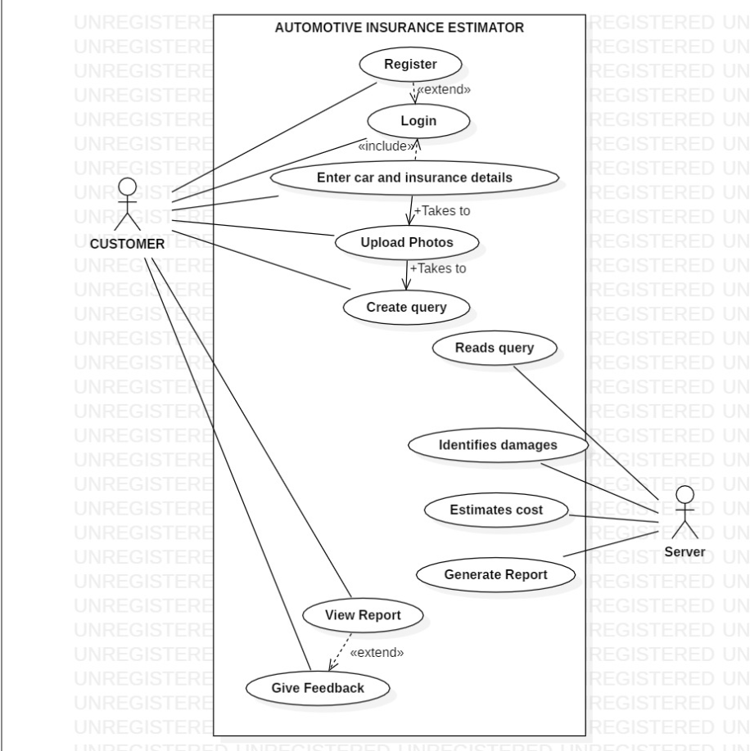

Fig 3.1 : Use Case Diagram showing the overview of the proposed system .

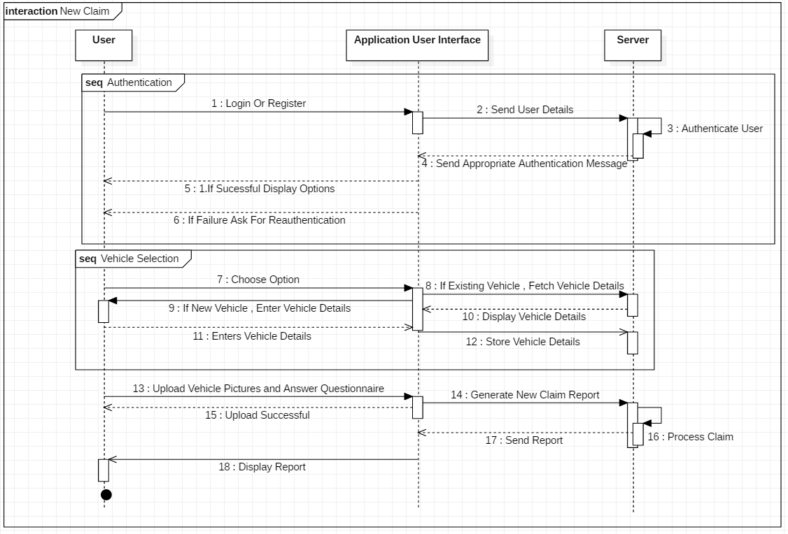

Fig 3.2 : Sequence Diagram representing steps for raising a new claim / estimate request

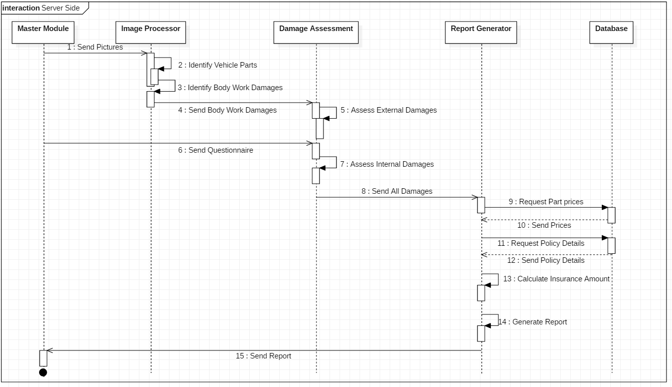

Fig 3.3 : Sequence Diagram representing steps taken by server for processing a claim request

**4. METHODS IMPLEMENTED**

For damage detection module of the proposed system, we have developed a Mask Regional-Convolution Neural Network (MRCNN) using the python’s tensorflow library as the base. To train the network for detection we used a 150 image set as training and validation inputs for 30 epochs, 250 steps per epoch, using coco weights as the base and training only the head layers of the network due to processing constraints of the available training machines. To display the detected damage area, we are testing two techniques to choose one of them. First method is such that the whole image is converted into grayscale and only intensity values of those pixels inside the detected area are retrieved from the original image. Second method is that a mask of different colour than that of detected area is drawn over the detected area.

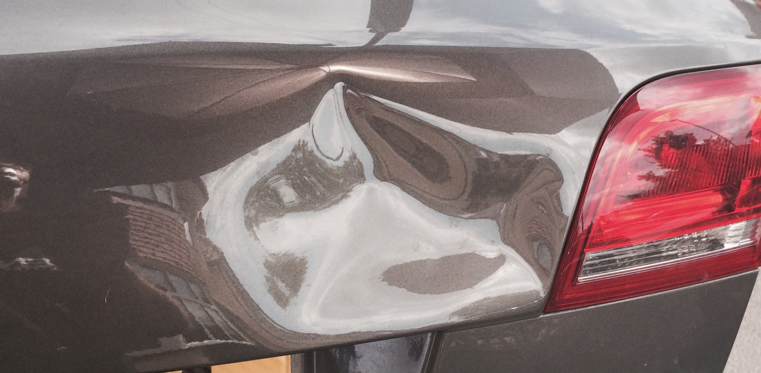

Fig 4.1 : The original input image

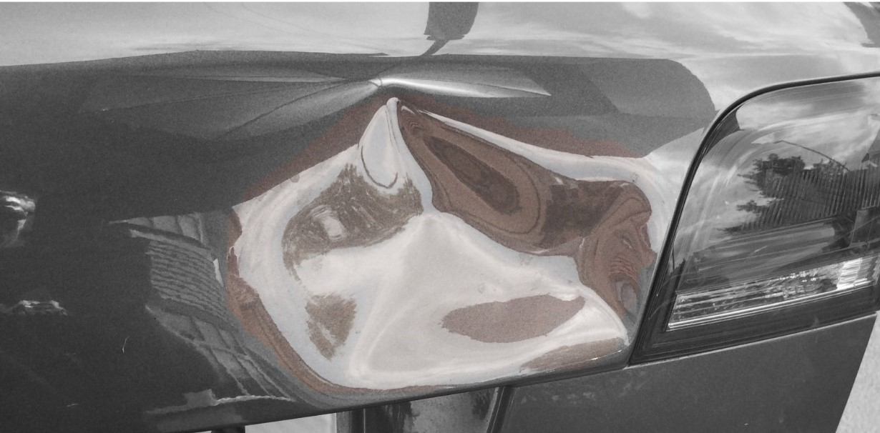

Fig 4.2 : The output image received using first method.

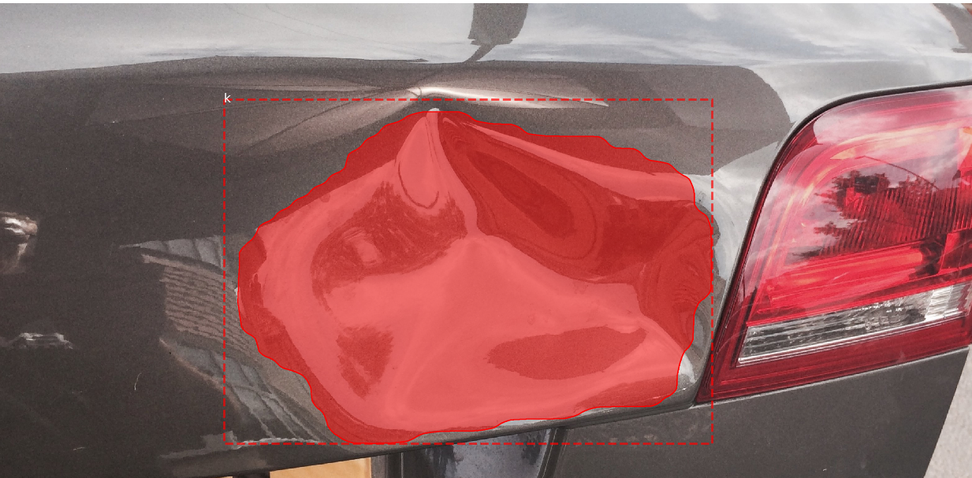

Fig 4.3 : The output image received using second method

The technologies used for the creation of the web page user interface so far are :-

Bootstrap:

The whole web page is styled with Bootstrap using the containers provided by the bootstrap, the navigation bar, the footer and the hero tag.

JavaScript:

Mostly the backend work for the animations and effects of smoothness of the user interface is done using JavaScript, for eg: the sticky navigation bar is made using Javascript.

Cascading Style Sheets:

The inline and in-tag styling is done using the in-line CSS and some specific colours are also put in the backgrounds using CSS since bootstrap wasn’t offering as many options in colours.

PHP:

PHP is used for the backend coding for the Website for the login and new user registration facility. Also, the data retrieval of a user will also be through PHP only.

SQL:

The database we will be using to store the general details of a user and his answers to our questionnaire will be stored in the SQL database.

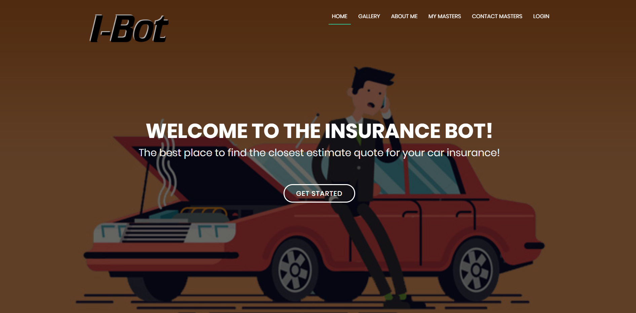

Fig 4.4 : Homepage of website

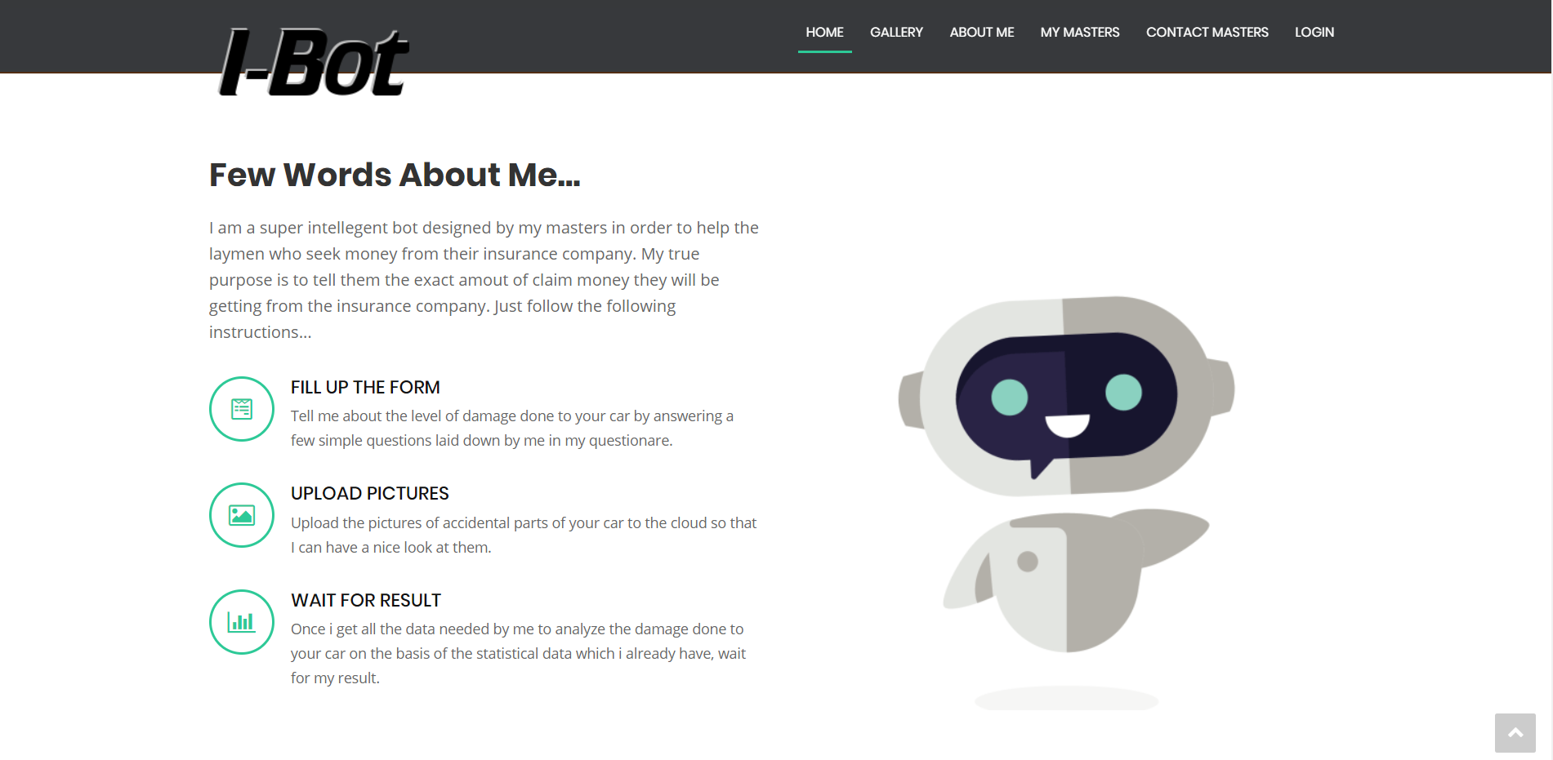

Fig 4.5 : Information page about Ibot

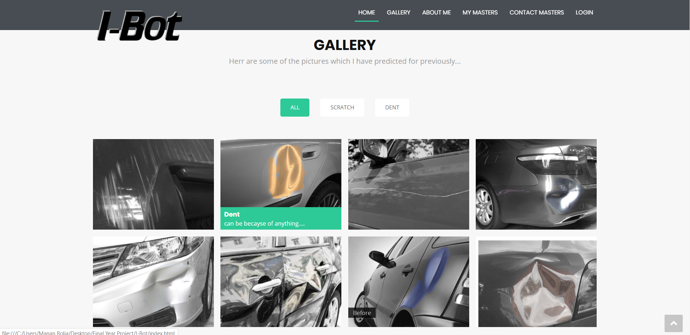

Fig 4.6 : Gallery of processed images

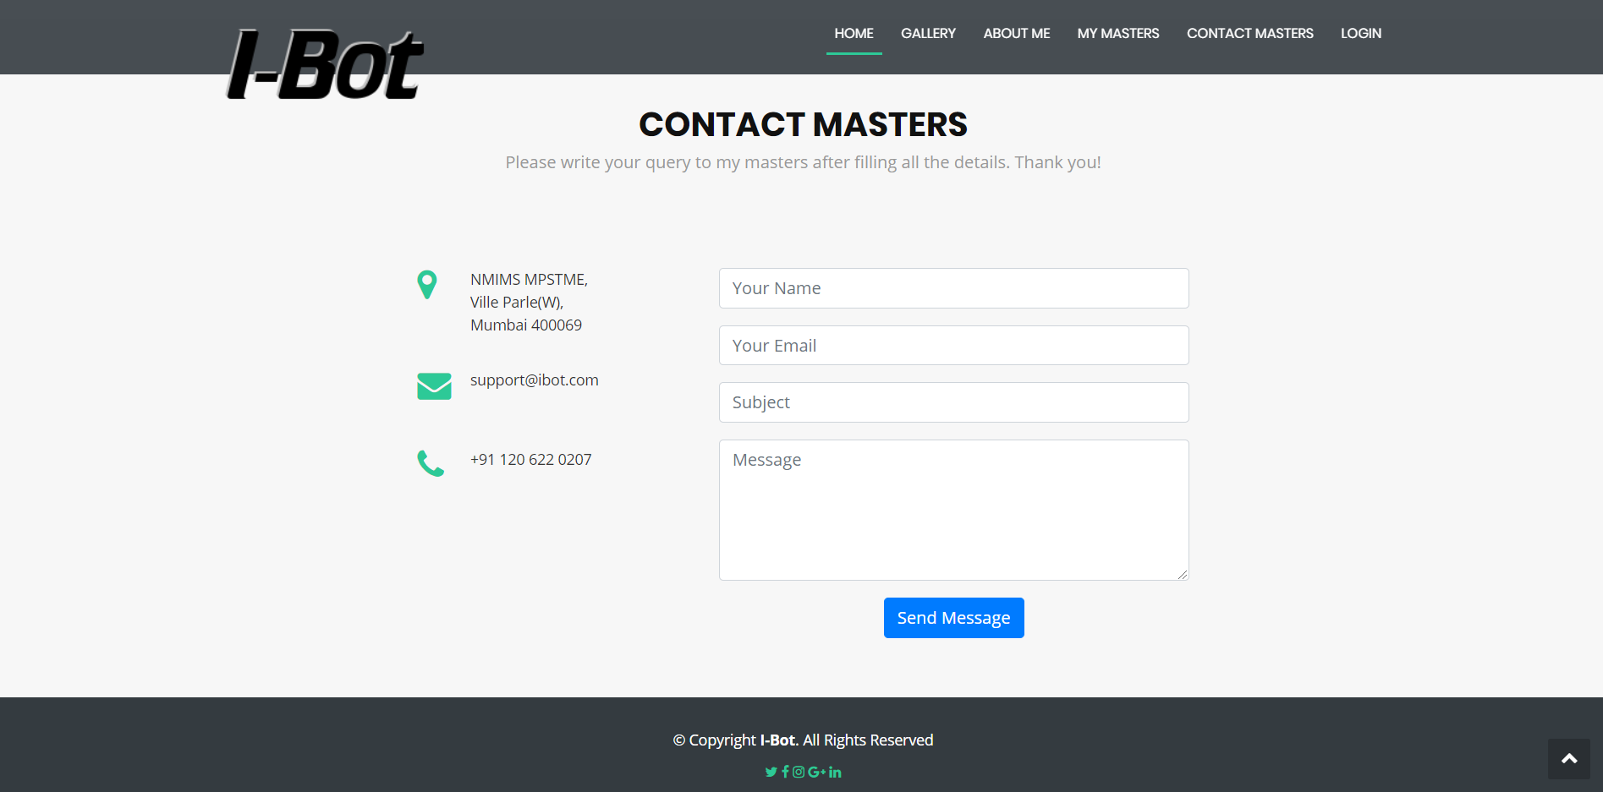Fig 4.7 : Query form

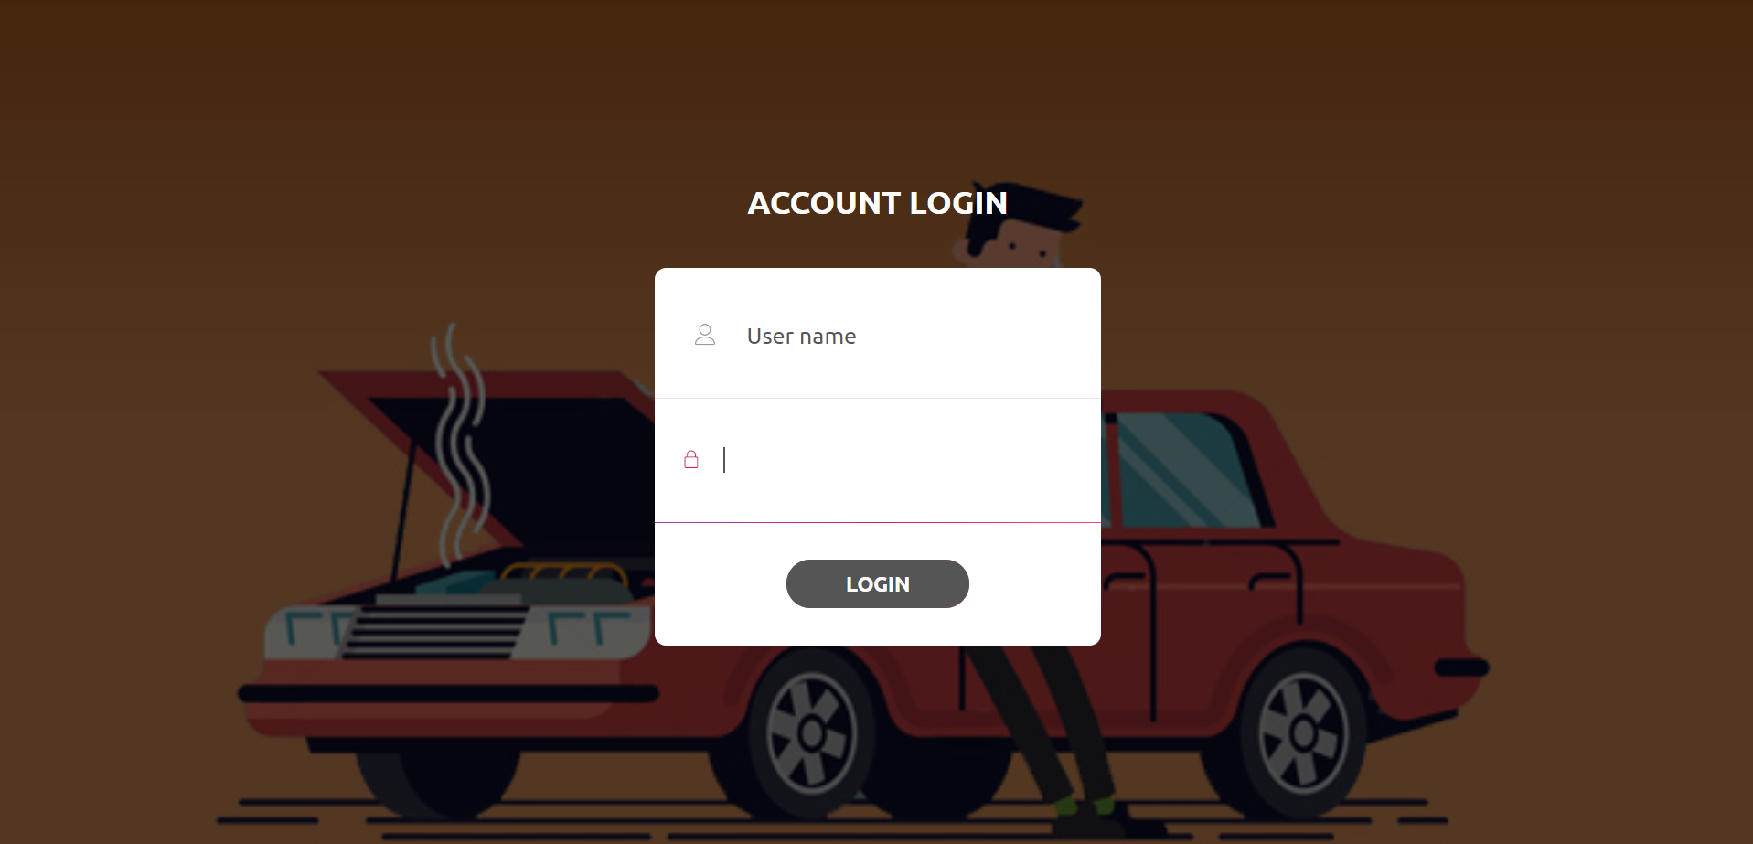

Fig 4.8 : Login Page

**5. RESULTS AND DISCUSSION**

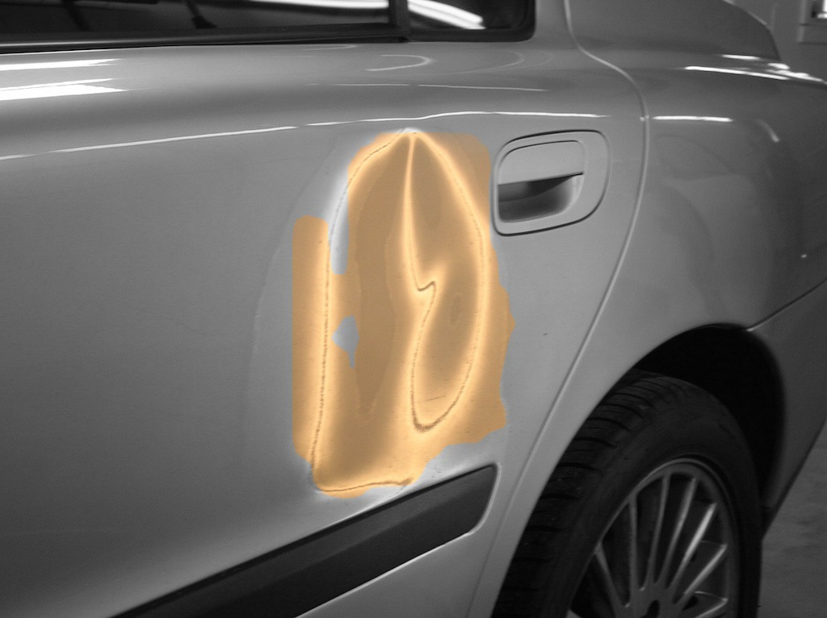

Fig 5.1 : Dent demarcated properly

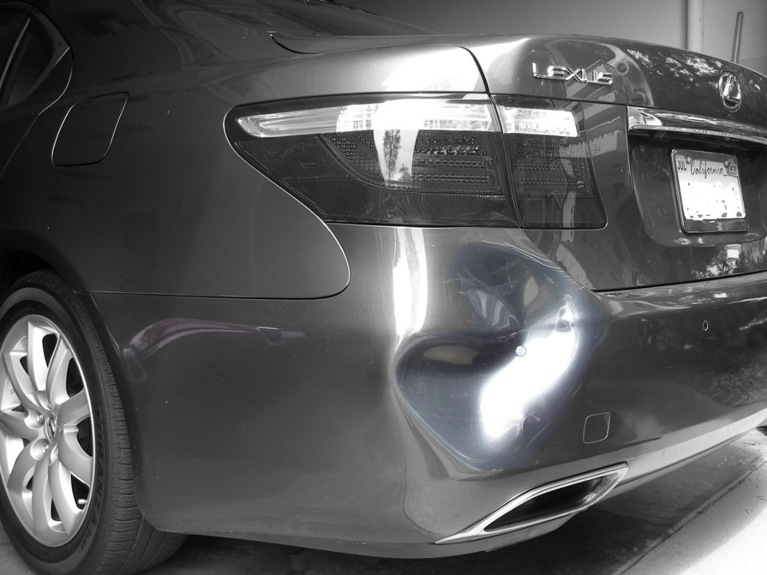

Fig 5.2 : Dent demarcated properly

As it can be observed in the above images that there is proper or very small error in the area detected as damaged part.

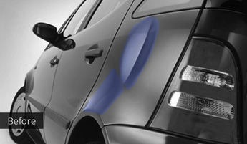

Fig 5.3 : Dent demarcated

As it can be seen in the image above , there is an extra damage detected , which in reality is not damage but the shape of the car.

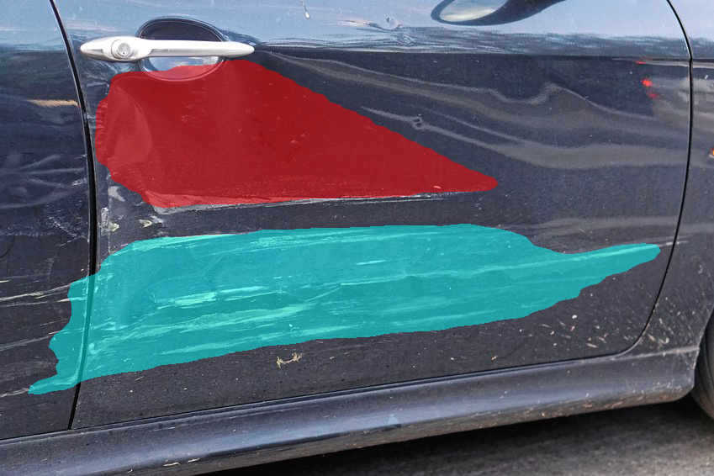

Fig 5.4 : Multiple damages are demarcated

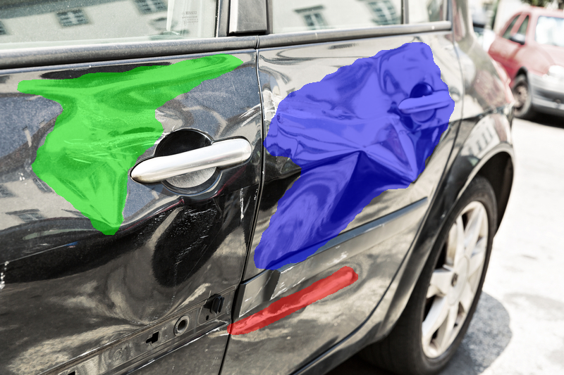

Fig 5.5 : Multiple Damages are demarcated

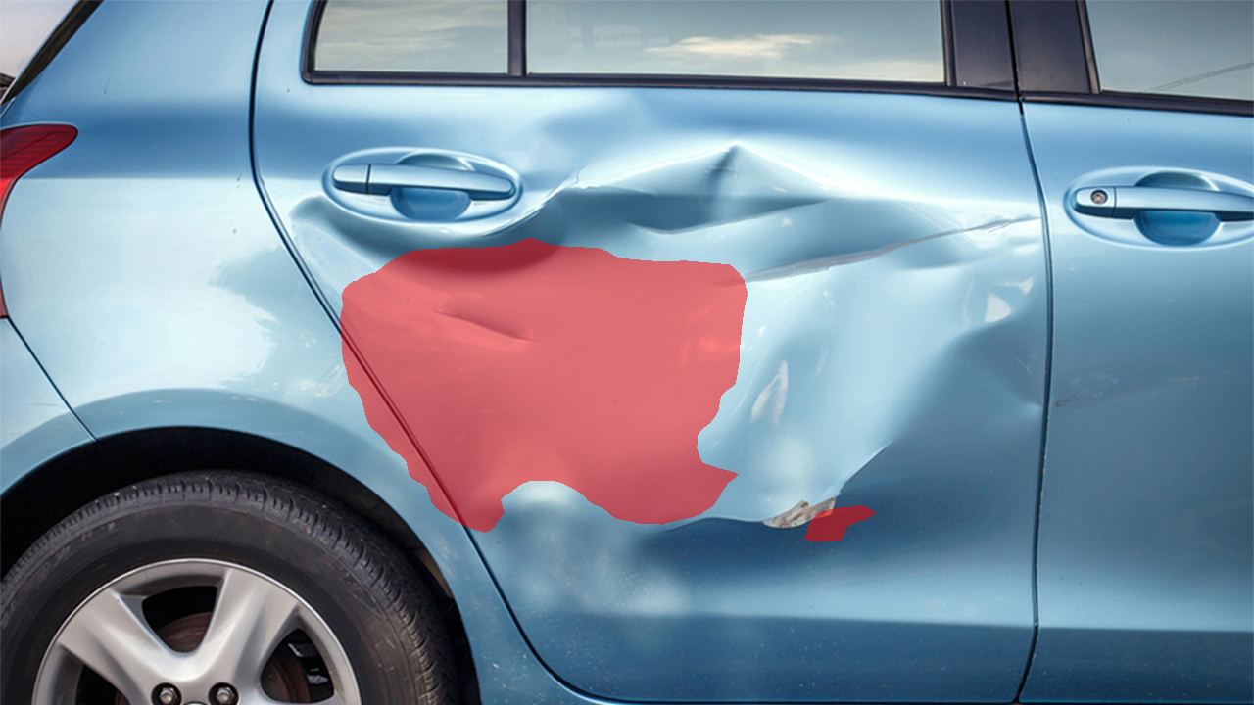

Fig 5.6: Multiple damages but not all marked

As it can be observed in the above images, the damage detection module is able to detect multiple damaged areas on the car but sometimes fails to identify all the damaged areas.

To increase the performance of the damage detection module, that is increase accuracy in the scenarios where not all damaged areas are demarcated, undamaged area is detected as damaged or undamaged surrounding of damaged areas is also considered as damaged part. To do the improvement we need to train more layers of the CNN, increase the training and validation dataset size, increasing steps per epoch and no of epochs. The proposed improvement steps could not be taken from the beginning due to limited processing power of the machines available with team. So to increase the processing power use of cloud computing like Microsoft Azure, Google Cloud Platform or Amazon AWS in being considered and compared based on resource being provided and their costs.

**6. CONCLUSION AND FUTURE SCOPE**

The proposed system will estimate the insurance claim amount for a car’s damage as a total sum of both internal as well as external damages suffered by the car. This process will be carried out without much hassle and the results will be obtained instantly on-the-spot. This will help the user in deciding whether he should go for the insurance claiming process or not because the entire process is very long and tiring, which also means that his car will not be available to him for a few days, starting from the day he raises a claim to the day the insurance company agent comes to his house for evaluating the damage suffered by the car and then taking all the details back to the company so that he can cross-verify the cost of parts and then give a claim amount based on the coverage offered by the insurance policy the user is on and then finally sending him a quote of the claim amount which will be provided, this whole process takes at least 5-7 days and then again it is not guaranteed that claim amount which the user will get will be sufficient to cover most of the damages. Through our system he can simply put in all the details and get an approximate insurance claim amount quote instantly on-the-spot and decide that will the amount which he will get from the insurance company is worth the wait and inconvenience for 5-7 days or he should just go to the local nearby mechanic and get it fixed locally if it’s costing the same, which is the purpose of this project.

This also gives you the option to say no to availing the insurance once you have seen the estimate of the claim amount you are going to get for the damage otherwise, in case of insurance companies, one you filed the report of your car damage and gotten the exact claim amount, you cannot say no to the company as they will treat it as the damage done to the car which was not accounted for and they might cancel your insurance. So yes, you don’t get an exact estimate of the amount which will be given to you but you do get a decent guesstimate and buy that you can understand the price range and make a decision, so this might be a trade off of the software that it does not provide exact cost but again it’s still saves you from all the hassle and inconveniences and you can decide not to claim the insurance amount even after getting an amount estimate which enormously outweighs the trade-off.

So conclusively, we can say that this software might not give us the exact estimate of the claim amount which is a small trade-off of the software but it still gives the user a very close estimate of the amount which is sufficient to make his decision and this saves him from a lot of inconveniences which enormously outweighs the trade-off.

**Future scope for this project includes:**

● Expanding the system’s capabilities to perform analysis on all types of car manufacturing companies.

● Expanding the system’s capabilities to calculate the claim value based on the type of insurance policy availed by the user.

● The questionnaire answered by the user can be replaced by an interactive ChatBot.

● Development of the system so as to completely eliminate the role of a middleman i.e. the surveyor.

● An app could also be developed to increase the reach and convenience of the system

● Working towards a better guesstimate over time as the database increases with practical real life cases.

● Getting the guesstimate given by the software more accurate, close to the actual estimate by learning from real cases which will be added to the database simultaneously.

**REFERENCES**

1. Accenture “Machine Learning in Insurance”
2. Anand Saukar, Kedar Pathare, Shweta Gode “An Overview On Web Scraping Techniques And Tools”, International Journal on Future Revolution in Computer Science & Communication Engineering, April, 2018.
3. Arjun Yogeswaran and Pierre Payeur “3D Surface Analysis for Automated Detection of Deformations on Automotive Body Panels”, August, 2012.
4. Domen Racki,Dejan Tomazevi,Danijel Skocaj “The effect of different CNN configurations on textured-surface defect segmentation and detection performance” 23rd Computer Vision Winter Workshop Czech Republic, February, 2018
5. Geethapriya. S, N. Duraimurugan, S.P. Chokkalingam “Real-Time Object Detection with Yolo ”, International Journal of Engineering and Advanced Technology (IJEAT), February, 2019.
6. ICICI Lombard “Intraspect: Instant Claim Approval”
7. Kaiming He Georgia Gkioxari Piotr Dollar Ross Girshick “Mask R-CNN Facebook AI Research (FAIR) 2018
8. Laura Arnal, J.Ernesto Solanes, Jaime Molina, Josep Tornero “Detecting dings and dents on specular car body surfaces based on optical flow”, Journal of Manufacturing Systems, October, 2017.
9. Madan Mohan Dutta, Gautam Mitra “Factors Affecting Auto Insurance In India”
10. Pratiksha Ashiwal , S.R.Tandan , Priyanka Tripathi , Rohit Miri “Web Information Retrieval Using Python and BeautifulSoup”,International Journal for Research in Applied Science & Engineering Technology (IJRASET) June 2016
11. Qinbang Zhou, Renwen Chen, Bin Huang, Chuan Liu, Jie Yu, Xiaoqing Yu “An Automatic Surface Defect Inspection System for Automobiles Using Machine Vision Methods”, Sensors, February, 2019.
12. Shaoqing Ren∗, Kaiming He, Ross Girshick, Jian Sun “Faster R-CNN: Towards Real-Time Object Detection with Region Proposal Networks”, Microsoft Research.
13. T. Lilienblum, P. Albrecht, R. Calow, B. Michaelis “Dent detection in car bodies”, Pattern Recognition, 2000. 15th International Conference, February, 2000.

**APPENDIX A : Soft Code**

**Login Algorithm**

1. Creation of HTML page which consists of:
   * Creation of title.
   * Calling CSS using bootstrap.
   * Selection of style
   * Addition of Footers and calling AJAX files.
2. CSS binding of HTML pages:
   * Selection of style
   * Positioning of tag
   * Positioning of place holders
   * Redirection to signup.
3. Form creation:
   * Addition of header files
   * Label for username and password
   * Initialization of button for signing in

**Register Algorithm**

1. Creation of HTML page which consists of:
   * Creation of title.
   * Calling CSS using bootstrap.
   * Selection of style
   * Addition of Footers and calling AJAX files.
2. CSS binding of HTML pages:
   * Selection of style
   * Positioning of tag
   * Positioning of place holders
3. Form creation:
   * Addition of header files
   * Label for Username, Password(2 times), Insurance type and company, car make/model and contact number
   * Initialization of button for signing up.
   * Redirection to Login.